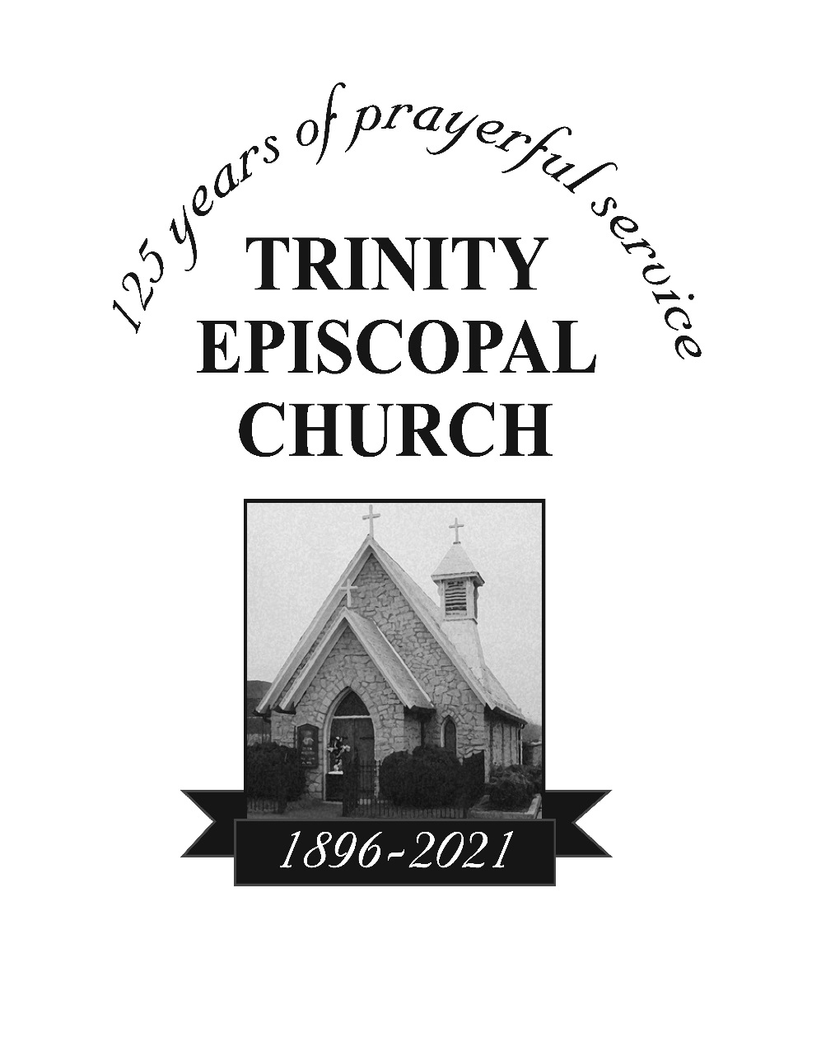

The Rev. Sarah Carper Morris, Rector

Larry Keesler, Organist/Choirmaster

The Sixteenth Sunday after Pentecost

September 12, 2021

8:00 am and 11:00 am

***Due to high COVID numbers in our county, masks are required at all times during indoor worship. Masks are available in the Narthex (back of the church).

Hymn in Procession The spacious firmament on high Hymn # 409
1 | The spacious firmament on high,
 | with all the blue eternal sky,
 | and spangled heavens, a shining frame,
 | their great Original proclaim.
 | The unwearied sun from day to day
 | does his Creator’s power display;
 | and publishes to every land
 | the work of an almighty hand.
2 | Soon as the evening shades prevail,
 | the moon takes up the wondrous tale,
 | and nightly to the listening earth
 | repeats the story of her birth:
 | whilst all the stars that round her burn,
 | and all the planets in their turn,
 | confirm the tidings, as they roll
 | and spread the truth from pole to pole.
3 | What though in solemn silence all
 | move round the dark terrestrial ball?
 | What though no real voice nor sound
 | amid their radiant orbs be found?
 | In reason’s ear they all rejoice,
 | and utter forth a glorious voice;
 | for ever singing as they shine,
 | “The hand that made us is divine.”

Celebrant Blessed be God: Father, Son, and Holy Spirit.
People And blessed be his kingdom, now and for ever. Amen.

The Collect for Purity Book of Common Prayer 355
Almighty God, to you all hearts are open, all desires known, and from you no secrets are hid: Cleanse the thoughts of our hearts by the inspiration of your Holy Spirit, that we may perfectly love you, and worthily magnify your holy Name; through Christ our Lord. Amen.

Gloria (sung) S-236

1 | Glory to you, Lord God of our fathers;
 | you are worthy of praise; glory to you.
2 | Glory to you for the radiance of your holy Name;
 | we will praise you and highly exalt you for ever.
3 | Glory to you in the splendor of your temple;
 | on the throne of your majesty, glory to you.
4 | Glory to you, seated between the Cherubim;
 | we will praise you and highly exalt you for ever.
5 | Glory to you, beholding the depths;
 | in the high vault of heaven, glory to you.
6 | Glory to you, Father, Son, and Holy Spirit;
 | we will praise you and highly exalt you for ever.

The Celebrant says to the people

The Lord be with you.
People And also with you.
Celebrant Let us pray.

The Collect (kneel or stand as you are able)
O God, because without you we are not able to please you, mercifully grant that your Holy Spirit may in all things direct and rule our hearts; through Jesus Christ our Lord, who lives and reigns with you and the Holy Spirit, one God, now and for ever. Amen.
Please be seated during the reading of the Lessons and the Psalm.

The First Lesson: Proverbs 1:20-33
Wisdom cries out in the street;
in the squares she raises her voice.
At the busiest corner she cries out;
at the entrance of the city gates she speaks:
“How long, O simple ones, will you love being simple?
How long will scoffers delight in their scoffing
and fools hate knowledge?
Give heed to my reproof;
I will pour out my thoughts to you;
I will make my words known to you.
Because I have called and you refused,
have stretched out my hand and no one heeded,
and because you have ignored all my counsel
and would have none of my reproof,
I also will laugh at your calamity;
I will mock when panic strikes you,
when panic strikes you like a storm,
and your calamity comes like a whirlwind,
when distress and anguish come upon you.
Then they will call upon me, but I will not answer;
they will seek me diligently, but will not find me.
Because they hated knowledge
and did not choose the fear of the Lord,
would have none of my counsel,
and despised all my reproof,
therefore they shall eat the fruit of their way
and be sated with their own devices.
For waywardness kills the simple,
and the complacency of fools destroys them;
but those who listen to me will be secure
and will live at ease, without dread of disaster.”

The Word of the Lord. People Thanks be to God.

Psalm 19 Caeli enarrant
1 The heavens declare the glory of God, *
and the firmament shows his handiwork.
2 One day tells its tale to another, *
and one night imparts knowledge to another.
3 Although they have no words or language, *
and their voices are not heard,
4 Their sound has gone out into all lands, *
and their message to the ends of the world.
5 In the deep has he set a pavilion for the sun; *
it comes forth like a bridegroom out of his chamber;
it rejoices like a champion to run its course.
6 It goes forth from the uttermost edge of the heavens
and runs about to the end of it again; *
nothing is hidden from its burning heat.
7 The law of the Lord is perfect
and revives the soul; *
the testimony of the Lord is sure
and gives wisdom to the innocent.
8 The statutes of the Lord are just
and rejoice the heart; *
the commandment of the Lord is clear
and gives light to the eyes.
9 The fear of the Lord is clean
and endures for ever; *
the judgments of the Lord are true
and righteous altogether.
10 More to be desired are they than gold,
more than much fine gold, *
sweeter far than honey,
than honey in the comb.
11 By them also is your servant enlightened, *
and in keeping them there is great reward.
12 Who can tell how often he offends? *
cleanse me from my secret faults.
13 Above all, keep your servant from presumptuous sins;
let them not get dominion over me; *
then shall I be whole and sound,
and innocent of a great offense.
14 Let the words of my mouth and the meditation of my
heart be acceptable in your sight, *
O Lord, my strength and my redeemer.

The Second Lesson: James 3:1-12
Not many of you should become teachers, my brothers and sisters, for you know that we who teach will be judged with greater strictness. For all of us make many mistakes. Anyone who makes no mistakes in speaking is perfect, able to keep the whole body in check with a bridle. If we put bits into the mouths of horses to make them obey us, we guide their whole bodies. Or look at ships: though they are so large that it takes strong winds to drive them, yet they are guided by a very small rudder wherever the will of the pilot directs. So also the tongue is a small member, yet it boasts of great exploits.
How great a forest is set ablaze by a small fire! And the tongue is a fire. The tongue is placed among our members as a world of iniquity; it stains the whole body, sets on fire the cycle of nature, and is itself set on fire by hell. For every species of beast and bird, of reptile and sea creature, can be tamed and has been tamed by the human species, but no one can tame the tongue-- a restless evil, full of deadly poison. With it we bless the Lord and Father, and with it we curse those who are made in the likeness of God. From the same mouth come blessing and cursing. My brothers and sisters, this ought not to be so. Does a spring pour forth from the same opening both fresh and brackish water? Can a fig tree, my brothers and sisters, yield olives, or a grapevine figs? No more can salt water yield fresh.

The Word of the Lord. People Thanks be to God.

Sequence Hymn When I survey the wondrous cross Hymn # 474
1 | When I survey the wondrous cross
 | where the young Prince of Glory died,
 | my richest gain I count but loss,
 | and pour contempt on all my pride.
2 | Forbid it, Lord, that I should boast,
 | save in the cross of Christ, my God:
 | all the vain things that charm me most,
 | I sacrifice them to his blood.
3 | See, from his head, his hands, his feet
 | sorrow and love flow mingled down!
 | Did e’er such love and sorrow meet,
 | or thorns compose so rich a crown?
4 | Were the whole realm of nature mine,
 | that were an offering far too small;
 | love so amazing, so divine,
 | demands my soul, my life, my all.

The Gospel: Mark 8:27-38 (stand as you are able)
The Holy Gospel of our Lord Jesus Christ
according to Mark.
People Glory to you, Lord Christ.
Jesus went on with his disciples to the villages of Caesarea Philippi; and on the way he asked his disciples, “Who do people say that I am?” And they answered him, “John the Baptist; and others, Elijah; and still others, one of the prophets.” He asked them, “But who do you say that I am?” Peter answered him, “You are the Messiah.” And he sternly ordered them not to tell anyone about him.
Then he began to teach them that the Son of Man must undergo great suffering, and be rejected by the elders, the chief priests, and the scribes, and be killed, and after three days rise again. He said all this quite openly. And Peter took him aside and began to rebuke him. But turning and looking at his disciples, he rebuked Peter and said, “Get behind me, Satan! For you are setting your mind not on divine things but on human things.”
He called the crowd with his disciples, and said to them, “If any want to become my followers, let them deny themselves and take up their cross and follow me. For those who want to save their life will lose it, and those who lose their life for my sake, and for the sake of the gospel, will save it. For what will it profit them to gain the whole world and forfeit their life? Indeed, what can they give in return for their life? Those who are ashamed of me and of my words in this adulterous and sinful generation, of them the Son of Man will also be ashamed when he comes in the glory of his Father with the holy angels.”
The Gospel of the Lord.
People Praise to you, Lord Christ.

Sermon The Rev. Sarah Carper Morris

The Nicene Creed

We believe in one God,
the Father, the Almighty,
maker of heaven and earth,
of all that is, seen and unseen.

We believe in one Lord, Jesus Christ,
the only Son of God,
eternally begotten of the Father,
God from God, Light from Light,
true God from true God,
begotten, not made,
of one Being with the Father.
Through him all things were made.
For us and for our salvation
he came down from heaven:
by the power of the Holy Spirit
he became incarnate from the Virgin Mary,
and was made man.
For our sake he was crucified under Pontius Pilate;
he suffered death and was buried.
On the third day he rose again
in accordance with the Scriptures;
he ascended into heaven
and is seated at the right hand of the Father.
He will come again in glory to judge the living and the dead,
and his kingdom will have no end.

We believe in the Holy Spirit, the Lord, the giver of life,
who proceeds from the Father and the Son.
With the Father and the Son he is worshiped and glorified.
He has spoken through the Prophets.
We believe in one holy catholic and apostolic Church.
We acknowledge one baptism for the forgiveness of sins.
We look for the resurrection of the dead,
and the life of the world to come. Amen.

The Prayers of the People Form III BCP p. 387

The Leader and People pray responsively

Father, we pray for your holy Catholic Church;
That we all may be one.

Grant that every member of the Church may truly and humbly serve you;
That your Name may be glorified by all people.

We pray for all bishops, priests, and deacons;
That they may be faithful ministers of your Word and Sacraments.

We pray for all who govern and hold authority in the nations of the world;
That there may be justice and peace on the earth.

Give us grace to do your will in all that we undertake;
That our works may find favor in your sight.

Have compassion on those who suffer from any grief or trouble;
That they may be delivered from their distress.

Give to the departed eternal rest;
Let light perpetual shine upon them.

We praise you for your saints who have entered into joy;
May we also come to share in your heavenly kingdom.

Let us pray for our own needs and those of others.

Silence

The People may add their own petitions.

The Celebrant adds a concluding Collect.

Confession of Sin

The Deacon or Celebrant says

Let us confess our sins against God and our neighbor.

Silence may be kept.

Minister and People

Most merciful God,
we confess that we have sinned against you
in thought, word, and deed,
by what we have done,
and by what we have left undone.
We have not loved you with our whole heart;
we have not loved our neighbors as ourselves.
We are truly sorry and we humbly repent.
For the sake of your Son Jesus Christ,
have mercy on us and forgive us;
that we may delight in your will,
and walk in your ways,
to the glory of your Name. Amen.

The Bishop when present, or the Priest, stands and says

Almighty God have mercy on you, forgive you all your sins through our Lord Jesus Christ, strengthen you in all goodness, and by the power of the Holy Spirit keep you in eternal life. Amen.

The Peace BCP 360

All stand. The Celebrant says to the people

The peace of the Lord be always with you.
People And also with you.

Announcements

Offertory and Doxology
Praise God, from whom all blessings flow;
praise him, all creatures here below;
praise him above, ye heavenly host:
praise Father, Son, and Holy Ghost.

Eucharistic Prayer B BCP 367

Stand as you are able. The Celebrant faces the people and sings or says

The Lord be with you.
People And also with you.
Celebrant Lift up your hearts.
People We lift them to the Lord.
Celebrant Let us give thanks to the Lord our God.
People It is right to give him thanks and praise.

Then, facing the Holy Table, the Celebrant proceeds

It is right, and a good and joyful thing, always and everywhere to give thanks to you, Father Almighty, Creator of heaven and earth.

For you are the source of light and life; you made us in your image, and called us to new life in Jesus Christ our Lord.

Therefore we praise you, joining our voices with Angels and Archangels and with all the company of heaven, who for ever sing this hymn to proclaim the glory of your Name:

Stand or kneel as you are able

Then the Celebrant continues

The Hymnal 1982, Service Music - #125 The Holy Eucharist II, Holy, holy, holy Lord: Sanctus
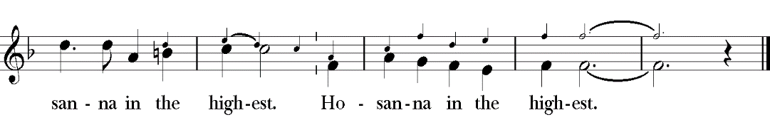
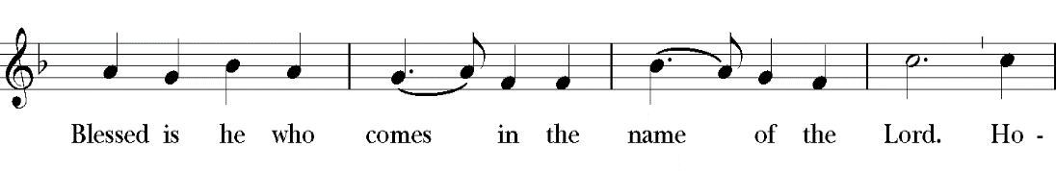
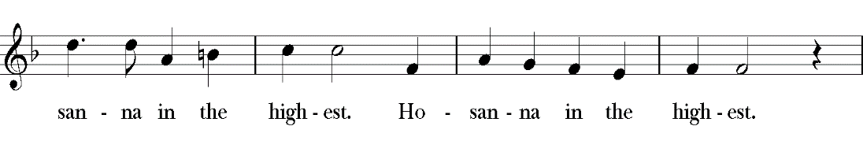
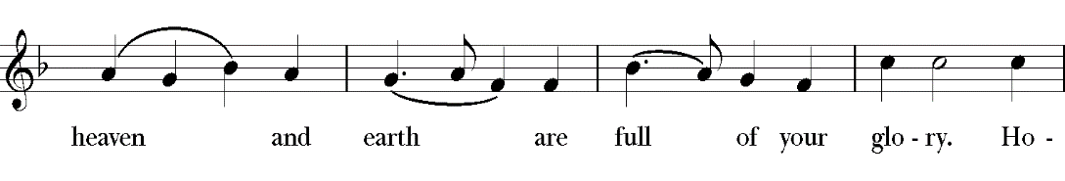
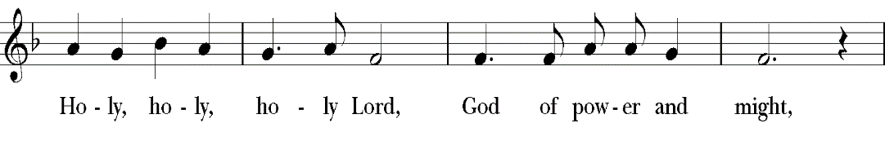

Stand or kneel as you are able

Then the Celebrant continues

We give thanks to you, O God, for the goodness and love which you have made known to us in creation; in the calling of Israel to be your people; in your Word spoken through the prophets; and above all in the Word made flesh, Jesus, your Son.

For in these last days you sent him to be incarnate from the Virgin Mary, to be the Savior and Redeemer of the world. In him, you have delivered us from evil, and made us worthy to stand before you. In him, you have brought us out of error into truth, out of sin into righteousness, out of death into life.

On the night before he died for us, our Lord Jesus Christ took bread; and when he had given thanks to you, he broke it, and gave it to his disciples, and said, “Take, eat: This is my Body, which is given for you. Do this for the remembrance of me.”

After supper he took the cup of wine; and when he had given thanks, he gave it to them, and said, “Drink this, all of you: This is my Blood of the new Covenant, which is shed for you and for many for the forgiveness of sins. Whenever you drink it, do this for the remembrance of me.”

Therefore, according to his command, O Father,

Celebrant and People

We remember his death,
We proclaim his resurrection,
We await his coming in glory;

The Celebrant continues

And we offer our sacrifice of praise and thanksgiving to you, O Lord of all; presenting to you, from your creation, this bread and this wine.

We pray you, gracious God, to send your Holy Spirit upon these gifts that they may be the Sacrament of the Body of Christ and his Blood of the new Covenant. Unite us to your Son in his sacrifice, that we may be acceptable through him, being sanctified by the Holy Spirit.

In the fullness of time, put all things in subjection under your Christ, and bring us to that heavenly country where, with [ ___________ and] all your saints, we may enter the everlasting heritage of your sons and daughters; through Jesus Christ our Lord, the firstborn of all creation, the head of the Church, and the author of our salvation.

By him, and with him, and in him, in the unity of the Holy Spirit all
honor and glory is yours, Almighty Father, now and for ever.
People AMEN.

And now, as our Savior
Christ has taught us,
we are bold to say,

People and Celebrant

Our Father, who art in heaven,
hallowed be thy Name,
thy kingdom come,
thy will be done,
on earth as it is in heaven.
Give us this day our daily bread.
And forgive us our trespasses,
as we forgive those
who trespass against us.
And lead us not into temptation,
but deliver us from evil.
For thine is the kingdom,
and the power, and the glory,
for ever and ever. Amen.

The Breaking of the Bread

The Celebrant breaks the consecrated Bread.

Celebrant Alleluia. Christ our Passover is sacrificed for us;
People Therefore let us keep the feast. Alleluia.

A period of silence is kept.

Then may be sung or said

Fraction Anthem (Celebrant and People) Hymnal S-154

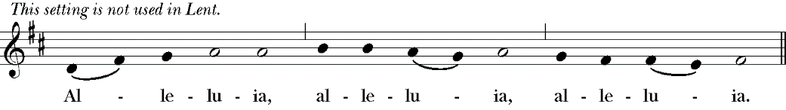
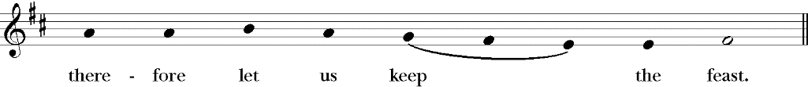
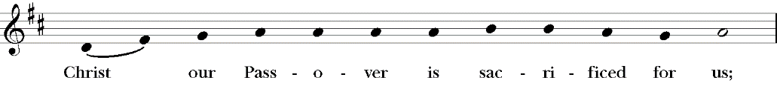
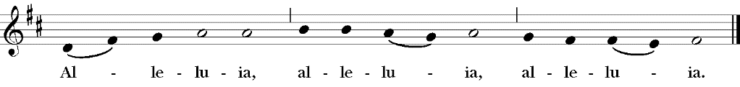

The Gifts of God for the People of God.

The ministers receive the Sacrament in both kinds, and then immediately deliver it to the people.

The priest will bring communion to you in one kind saying:

The body and blood of our Lord Jesus Christ keep you in everlasting life. Amen.

After Communion, the Celebrant says

Let us pray.

Celebrant and People

Eternal God, heavenly Father, you have graciously accepted us as living members of your Son our Savior Jesus Christ, and you have fed us with spiritual food in the Sacrament of his Body and Blood.

Send us now into the world in peace, and grant us strength and courage
to love and serve you with gladness and singleness of heart; through Christ our Lord. Amen.

Blessing

Celebrant Life is short, and we do not have much time to gladden the hearts of those who make the journey with us. So be swift to love, and make haste to be kind. And the blessing of God, who made us, who loves us, and who travels with us, be with you now and for ever.
People Amen.

Hymn in Procession Take up your cross, the Savior said Hymn # 675
1 | Take up your cross, the Savior said,
 | if you would my disciple be;
 | take up your cross with willing heart,
 | and humbly follow after me.
2 | Take up your cross, let not its weight
 | fill your weak spirit with alarm;
 | his strength shall bear your spirit up,
 | and brace your heart, and nerve your arm.
3 | Take up your cross, heed not the shame,
 | and let your foolish heart be still;
 | the Lord for you accepted death
 | upon a cross, on Calvary’s hill.
4 | Take up your cross, then, in his strength,
 | and calmly every danger brave:
 | it guides you to abundant life
 | and leads to victory o’er the grave.
5 | Take up your cross, and follow Christ,
 | nor think till death to lay it down;
 | for only those who bear the cross
 | may hope to wear the glorious crown.

Dismissal
Let us go forth in the name of Christ.
People Thanks be to God.

Copyrighted music used with permission under
ONE LICENSE #737635-A. All rights reserved.
Valid for: 12/16/2020 – 12/15/2021

PRAYERS AND REMEMBRANCES OF THE WEEK

Immediate Needs:
Erin Apperson
Janet Badgett
Tina Brown
Mazie Chilton
Mary Couture
Anne Cox
Kevin Cox
Sonia Donnell
Jasper Elliott
Marcus Ford
Raelynn Harp
Peter Hess
Yvette Jones
Larry Keesler
Mike Keziah
John Kidwell
Polly Kidwell
Amory King
Joy King
Carrie Krahn
Linda Light

If you would like yourself or someone else included, please call the church office.

TRINITY FAMILY IN THE ARMED SERVICES
OF OUR COUNTRY
Amanda Eads, Wesley Frye, Corbin Humphrey, Matt Kroupa, Glenn Lynch, Gordon Lynch, Haley Muething, John Nichols, Christopher Noble, Robert Poole
& Matthew Quilliman.

DIOCESAN CYCLE OF PRAYER
Trinity Church, Statesville
Calvary Church, Tarboro

FLOWERS
The flowers on the altar are given to the glory of God and in celebration of Abbie’s (my daughter) 30th birthday. Also in thanksgiving for my grandson, Jackson Longmire Gray, and blessings to his parents, Austin and Lindsay. You all are my world - Love Theresa Gray

Rick & Jane
Susanna Metz
John Moore
Michael Morgan
Craig New

Angie Nolfo

Susan Olchak

Bill R. Pendleton

Kerry Reagan

Brett Rogers

Candace Sammons
Evedene Schafer
Kevin Simmons
Tracy Speight
Sid Spencer, Jr.
Tammy Springthorpe
Chuck Stein
Carolyn Town
RJ Wilhite

Betty Wright

Bud Yokley

Pat Zebrowski

Long Term Needs:
*Anonymous
Theresa Caravello
Ann Cochrane
Kat Cook
Jim Couture
Melissa Roth Culver
Ron Doerschug
Linda Doerschug
Donna Fargo
Lorien Gilliand
Betty Grady
Linda Hicks
Betty Hooven
Kelly Jarvis

BJ Johnson

Sandy Johnson
David Kroupa
Angelia Lawrence
Martha Marcum
Will Merritt

Wade Nichols

David S.

Betty Town
Vicky Town

Mike Wilson
Jack Woltz

Hope Zimmerman

ANNOUNCEMENTS

Due to high county COVID numbers, the Diocese of NC has instructed that everyone must wear a mask during indoor services.

We will continue having 3 services for the summer at 8:00 a.m. indoors/no music, 9:15 a.m. outside with guitar accompaniment, 11:00 a.m. indoors with organ. For safety purposes until our local COVID numbers decrease, we will not be having Lemonade on the Lawn or Coffee Hour.

The Vestry will meet on Tuesday, September 14th at 6:00 p.m.

Knit One, Pray Too will meet on Wednesday, September 15th at 2:00 p.m. in the Parish Hall.

The Journey to Racial Equality Session 3 begins this week.
- Sept. 14, 7 p.m.: Webinar with Debby Irving, author of Waking Up White
- Sept. 19 - Oct. 10: 21-Day Challenge
- Oct. 12, 7 p.m.: Webinar with Bishop William Barber, II, senior lecturer of Repairers of the Breach
Join Team Trinity for the Walk to End Alzheimer’s on September 18th at Riverside Park, Mount Airy. Register/Donate at www.alz.org or call Margie Martin at 336-755-3242.

The Altar Guild will host and short class on Sunday, September 26th followed by a light luncheon. Please RSVP to the church office if you are able to attend.

Are you interested? There will be a mission trip to Canton, NC October 1-2/3. We will be going to assist in an area affected by floodwaters. Please let Sarah know if you’d like to go. We will stay at Lake Junaluska and meet there at 10 on Friday.

Trinity T-shirts! Today is the last day to order! Available in blue or red, they are $15 each and you can pay when they come in. Order forms can be found in the narthex or at the back door.

If you are visiting, please fill out a Visitor Card and put it in the offering plate or hand it to a greeter.

BIRTHDAYS

September 17th John Springthorpe, III & William Woltz, III

MINISTERS FOR THE 8:00 SERVICE
This Sunday Ministry Next Sunday
Vicky Town LECTOR Ann Cochrane

Mike Wilson GREETER Pat Sanderson

MINISTERS FOR THE 9:15 SERVICE
This Sunday Ministry Next Sunday
Suzanne Settle LECTOR Kellan Wilsonwithers

Tom & Pam D. GREETERS The Fallins

MINISTERS FOR THE 11:00 SERVICE
This Sunday Ministry Next Sunday
Wade Nichols LECTOR James Derrick
Kate & Wendy GREETERS Ross & Janet Sos.
Kate Appler VESTRY PERSON James Derrick
Pat Gallagher ALTAR GUILD Wendy Tatman

THIS WEEK'S EVENTS
Today 8:00 a.m. Holy Communion, Rite II
9:15 a.m. Holy Communion, Rite II
11:00 a.m. Holy Communion, Rite II

Tuesday 10:00 a.m. Loan Closet

Wednesday 5:30 p.m. Holy Communion

Thursday 8:30 a.m. Staples
3:00 p.m. Loan Closet

Next Sunday 8:00 a.m. Holy Communion, Rite II
9:15 a.m. Holy Communion, Rite II
11:00 a.m. Holy Communion, Rite II

TRINITY VESTRY

Kate Appler, James Derrick, Lucinda Fallin,

Mary Fawcett, Senior Warden, Margie Martin,

Mac Sammons, Junior Warden, Jesse Slate,

Janet Sosnowski, James Tatman

No matter where you come from or where you're going
No matter what you believe or what you doubt
No matter what you feel or just don't feel today
No matter whom you love
You are welcome into this space to be met by a God
Who knows you by name, who knows your heart, who knows your mind, and…
Who wants to have a relationship with you

