TRINITY EPISCOPAL CHURCH
472 N. Main St./PO Box 1043
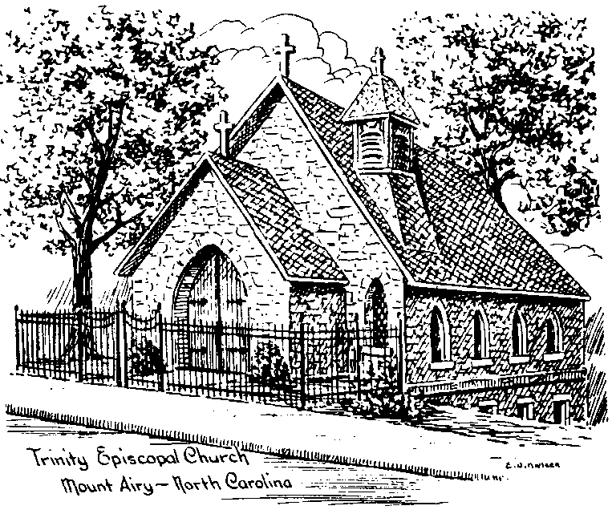
Mount Airy, NC 27030-1043
336-786-6067
email: info@trinitymtairy.com
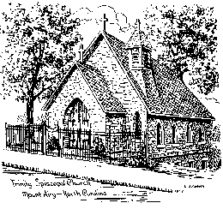

The Rev. Sarah Carper Morris, Rector

The Rev. Bill Pendleton, Deacon

Dr. Ryan Whittington, Organist

The Ninth Sunday after Pentecost

July 30, 2023

Kid’s bags are in the narthex. Please return the bags and they will be refilled for next Sunday.

Please remember that many are preparing for worship with prayer before the service.

Hymn in Procession # 9 (standing as you are able)
1 Not here for high and holy things
we render thanks to thee,
but for the common things of earth,
the purple pageantry
of dawning and of dying days,
the splendor of the sea,

2 the royal robes of autumn moors,
the golden gates of spring,
the velvet of soft summer nights,
the silver glistering
of all the million million stars,
the silent song they sing,

3 of faith and hope and love undimmed,
undying still through death,
the resurrection of the world,
what time there comes the breath
of dawn that rustles through the trees,
and that clear voice that saith:

4 Awake, awake to love and work!
The lark is in the sky,
the fields are wet with diamond dew,
the worlds awake to cry
their blessings on the Lord of life,
as he goes meekly by.

5 Come, let thy voice be one with theirs,
shout with their shout of praise;
see how the giant sun soars up,
great lord of years and days!
So let the love of Jesus come
and set thy soul ablaze,

6 to give and give, and give again,
what God hath given thee;
to spend thyself nor count the cost;
to serve right gloriously
the God who gave all worlds that are,
and all that are to be.
Celebrant Blessed be God: Father, Son, and Holy Spirit.
People And blessed be his kingdom, now and for ever. Amen.

The Collect for Purity BCP p. 355
Almighty God, to you all hearts are open, all desires known, and from you no secrets are hid: Cleanse the thoughts of our hearts by the inspiration of your Holy Spirit, that we may perfectly love you, and worthily magnify your holy Name; through Christ our Lord. Amen.

Song of Praise Hymn # S278
Glory to God in the highest,
and peace to his people on earth.

Lord God, heavenly King,
almighty God and Father,
we worship you, we give you thanks,
we praise you for your glory.

Lord Jesus Christ, only Son of the Father,
Lord God, Lamb of God,
you take away the sin of the world;
have mercy on us;
you are seated at the right hand of the Father;
receive our prayer.

For you alone are the Holy One,
you alone are the Lord,
you alone are the Most High,
Jesus Christ,
with the Holy Spirit,
in the glory of God the Father. Amen.
The Collect (kneel or stand as you are able)
O God, the protector of all who trust in you, without whom nothing is strong, nothing is holy: Increase and multiply upon us your mercy; that, with you as our ruler and guide, we may so pass through things temporal, that we lose not the things eternal; through Jesus Christ our Lord, who lives and reigns with you and the Holy Spirit, one God, for ever and ever. Amen.

Please be seated during the reading of the Lessons and the Psalm.

The First Lesson: Genesis 29:15-28
Laban said to Jacob, “Because you are my kinsman, should you therefore serve me for nothing? Tell me, what shall your wages be?” Now Laban had two daughters; the name of the elder was Leah, and the name of the younger was Rachel. Leah’s eyes were lovely, and Rachel was graceful and beautiful. Jacob loved Rachel; so he said, “I will serve you seven years for your younger daughter Rachel.” Laban said, “It is better that I give her to you than that I should give her to any other man; stay with me.” So Jacob served seven years for Rachel, and they seemed to him but a few days because of the love he had for her.
Then Jacob said to Laban, “Give me my wife that I may go in to her, for my time is completed.” So Laban gathered together all the people of the place, and made a feast. But in the evening he took his daughter Leah and brought her to Jacob; and he went in to her. (Laban gave his maid Zilpah to his daughter Leah to be her maid.) When morning came, it was Leah! And Jacob said to Laban, “What is this you have done to me? Did I not serve with you for Rachel? Why then have you deceived me?”
Laban said, “This is not done in our country—giving the younger before the firstborn. Complete the week of this one, and we will give you the other also in return for serving me another seven years.” Jacob did so, and completed her week; then Laban gave him his daughter Rachel as a wife.

The Word of the Lord. People Thanks be to God.
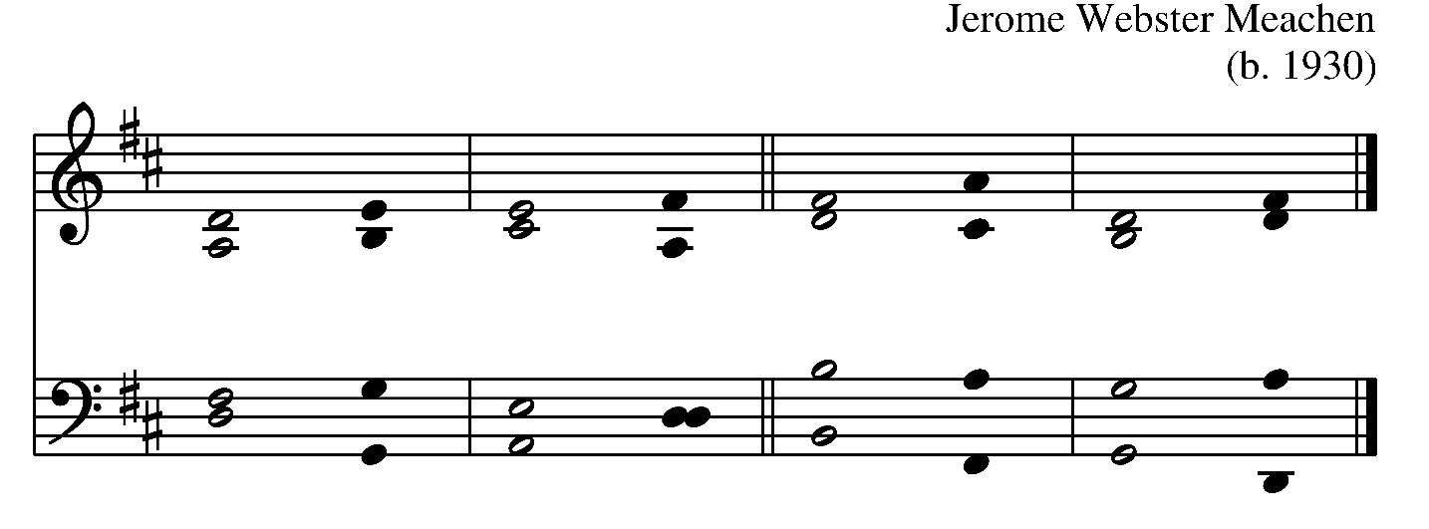
Psalm 128 Beati omnes
1 Happy are they all who fear the Lord, *
and who follow in his ways!
2 You shall eat the fruit of your labor; *
happiness and prosperity shall be yours.
3 Your wife shall be like a fruitful vine within your house, *
your children like olive shoots round about your table.
4 The man who fears the Lord *
shall thus indeed be blessed.
5 The Lord bless you from Zion, *
and may you see the prosperity of Jerusalem all the days of your life.
6 May you live to see your children's children; *
may peace be upon Israel.

The Second Lesson: Romans 8:26-39
The Spirit helps us in our weakness; for we do not know how to pray as we ought, but that very Spirit intercedes with sighs too deep for words. And God, who searches the heart, knows what is the mind of the Spirit, because the Spirit intercedes for the saints according to the will of God.
We know that all things work together for good for those who love God, who are called according to his purpose. For those whom he foreknew he also predestined to be conformed to the image of his Son, in order that he might be the firstborn within a large family. And those whom he predestined he also called; and those whom he called he also justified; and those whom he justified he also glorified.
What then are we to say about these things? If God is for us, who is against us? He who did not withhold his own Son, but gave him up for all of us, will he not with him also give us everything else? Who will bring any charge against God's elect? It is God who justifies. Who is to condemn? It is Christ Jesus, who died, yes, who was raised, who is at the right hand of God, who indeed intercedes for us. Who will separate us from the love of Christ? Will hardship, or distress, or persecution, or famine, or nakedness, or peril, or sword? As it is written,
“For your sake we are being killed all day long;
we are accounted as sheep to be slaughtered.”
No, in all these things we are more than conquerors through him who loved us. For I am convinced that neither death, nor life, nor angels, nor rulers, nor things present, nor things to come, nor powers, nor height, nor depth, nor anything else in all creation, will be able to separate us from the love of God in Christ Jesus our Lord.

The Word of the Lord. People Thanks be to God.
Sequence Hymn # 513 (standing as you are able)
1 Like the murmur of the dove’s song,
like the challenge of her flight,
like the vigor of the wind’s rush,
like the new flame’s eager might:
come, Holy Spirit, come.

2 To the members of Christ’s Body,
to the branches of the Vine,
to the Church in faith assembled,
to her midst as gift and sign:
come, Holy Spirit, come.

3 With the healing of division,
with the ceaseless voice of prayer,
with the power to love and witness,
with the peace beyond compare:
come, Holy Spirit, come.
Celebrant The Gospel of our Lord Jesus Christ according to Matthew.
People Glory to you, Lord Christ.

The Gospel: Matthew 13:31-33,44-52 (stand as you are able)
Jesus put before the crowds another parable: “The kingdom of heaven is like a mustard seed that someone took and sowed in his field; it is the smallest of all the seeds, but when it has grown it is the greatest of shrubs and becomes a tree, so that the birds of the air come and make nests in its branches.”
He told them another parable: “The kingdom of heaven is like yeast that a woman took and mixed in with three measures of flour until all of it was leavened.”
“The kingdom of heaven is like treasure hidden in a field, which someone found and hid; then in his joy he goes and sells all that he has and buys that field.
“Again, the kingdom of heaven is like a merchant in search of fine pearls; on finding one pearl of great value, he went and sold all that he had and bought it.
“Again, the kingdom of heaven is like a net that was thrown into the sea and caught fish of every kind; when it was full, they drew it ashore, sat down, and put the good into baskets but threw out the bad. So it will be at the end of the age. The angels will come out and separate the evil from the righteous and throw them into the furnace of fire, where there will be weeping and gnashing of teeth.
“Have you understood all this?” They answered, “Yes.” And he said to them, “Therefore every scribe who has been trained for the kingdom of heaven is like the master of a household who brings out of his treasure what is new and what is old.”
Celebrant The Gospel of the Lord.
People Praise to you, Lord Christ.
Sermon The Rev. Sarah Carper Morris
The Nicene Creed (standing as you are able)
We believe in one God,
the Father, the Almighty,
maker of heaven and earth,
of all that is, seen and unseen.

We believe in one Lord, Jesus Christ,
the only Son of God,
eternally begotten of the Father,
God from God, Light from Light,
true God from true God,
begotten, not made,
of one Being with the Father.
Through him all things were made.
For us and for our salvation
he came down from heaven:
by the power of the Holy Spirit
he became incarnate from the Virgin Mary,
and was made man.
For our sake he was crucified under Pontius Pilate;
he suffered death and was buried.

On the third day he rose again
in accordance with the Scriptures;
he ascended into heaven
and is seated at the right hand of the Father.
He will come again in glory to judge the living and the dead, and his kingdom will have no end.
We believe in the Holy Spirit, the Lord, the giver of life,
who proceeds from the Father and the Son.
With the Father and the Son he is worshiped and glorified.
He has spoken through the Prophets.
We believe in one holy catholic and apostolic Church.
We acknowledge one baptism for the forgiveness of sins.
We look for the resurrection of the dead,
and the life of the world to come. Amen.

The Prayers of the People Form III BCP p. 387

The Leader and People pray responsively

Father, we pray for your holy Catholic Church;
That we all may be one.

Grant that every member of the Church may truly and
humbly serve you;
That your Name may be glorified by all people.

We pray for all bishops, priests, and deacons;
That they may be faithful ministers of your Word and
Sacraments.

We pray for all who govern and hold authority in the nations of the world;
That there may be justice and peace on the earth.

Give us grace to do your will in all that we undertake;
That our works may find favor in your sight.

Have compassion on those who suffer from any grief or
trouble;
That they may be delivered from their distress.
Give to the departed eternal rest;
Let light perpetual shine upon them.

We praise you for your saints who have entered into joy;
May we also come to share in your heavenly kingdom.

Let us pray for our own needs and those of others.

Silence

The People may add their own petitions.

The Celebrant adds a concluding Collect.

Confession of Sin

The Deacon or Celebrant says

Let us confess our sins against God and our neighbor.

Silence may be kept.

Minister and People
Most merciful God,
we confess that we have sinned against you
in thought, word, and deed,
by what we have done,
and by what we have left undone.
We have not loved you with our whole heart;
we have not loved our neighbors as ourselves.
We are truly sorry and we humbly repent.
For the sake of your Son Jesus Christ,
have mercy on us and forgive us;
that we may delight in your will,
and walk in your ways,
to the glory of your Name. Amen.
The Bishop when present, or the Priest, stands and says

Almighty God have mercy on you, forgive you all your sins through our Lord Jesus Christ, strengthen you in all goodness, and by the power of the Holy Spirit keep you in eternal life. Amen.

The Peace BCP 360

All stand. The Celebrant says to the people

The peace of the Lord be always with you.
People And also with you.

Announcements

(8:30 service only)
Offertory

Celebrant All things come of Thee, O Lord.

People And of thine own have we given Thee.

(10:30 service only)
Offertory and Doxology Hymn 432, v.4 (standing)
O praise ye the Lord! Thanksgiving and song
To him be outpoured all ages along!
For love in creation, for heaven restored,
For grace of salvation, O praise ye the Lord!

Eucharistic Prayer C BCP. p. 369

The Celebrant, whether bishop or priest, faces them and sings or says

Celebrant The Lord be with you.
People And also with you.
Celebrant Lift up your hearts.
People We lift them to the Lord.
Celebrant Let us give thanks to the Lord our God.
People It is right to give him thanks and praise.

Then, facing the Holy Table, the Celebrant proceeds

God of all power, Ruler of the Universe, you are worthy of glory and praise.
Glory to you for ever and ever.

At your command all things came to be: the vast expanse of interstellar space, galaxies, suns, the planets in their courses, and this fragile earth, our island home.
By your will they were created and have their being.

From the primal elements you brought forth the human race, and blessed us with memory, reason, and skill. You made us the rulers of creation. But we turned against you, and betrayed your trust; and we turned against one another.
Have mercy, Lord, for we are sinners in your sight.

Again and again, you called us to return. Through prophets and sages you revealed your righteous Law. And in the fullness of time you sent your only Son, born of a woman, to fulfill your Law, to open for us the way of freedom and peace.
By his blood, he reconciled us.
By his wounds, we are healed.

And therefore we praise you, joining with the heavenly chorus, with prophets, apostles, and martyrs, and with all those in every generation who have looked to you in hope, to proclaim with them your glory, in their unending hymn:

Celebrant and People

The Holy Eucharist II, Holy, holy, holy Lord: Sanctus
The Hymnal 1982, Service Music, #125
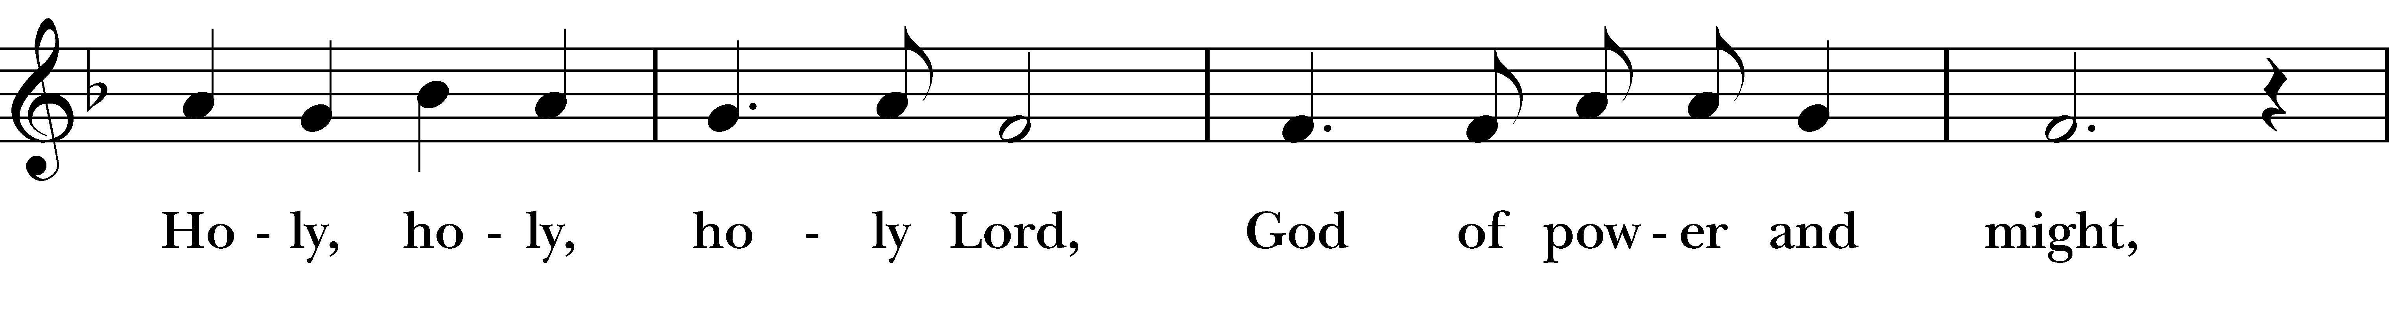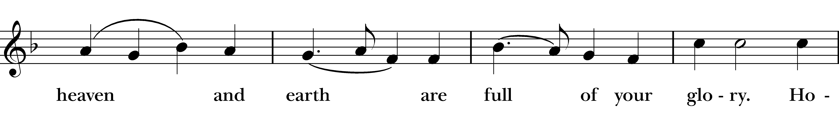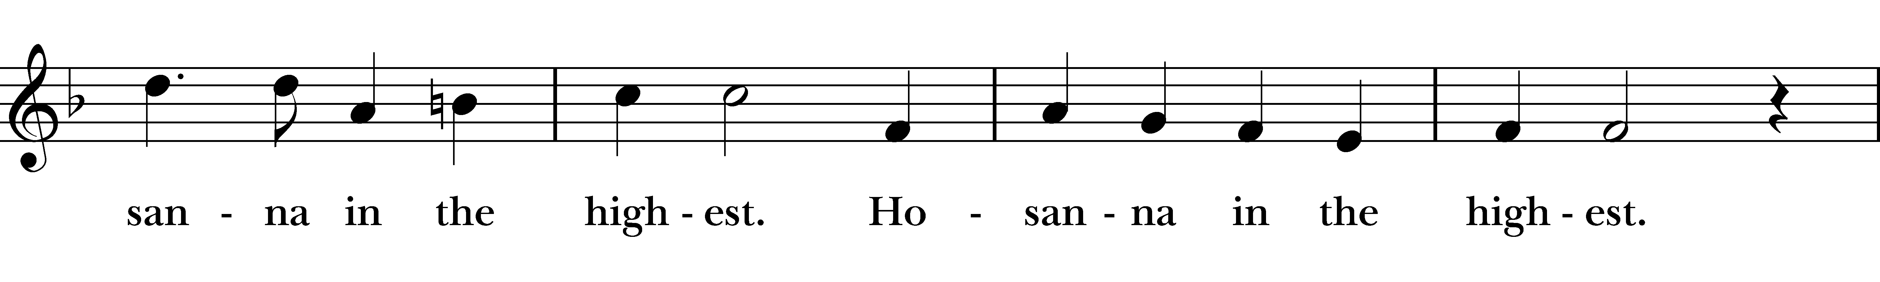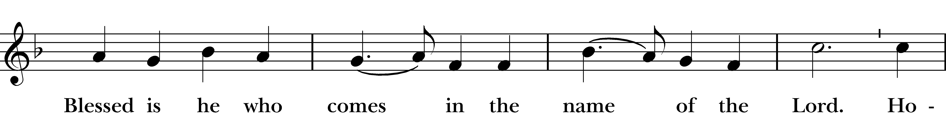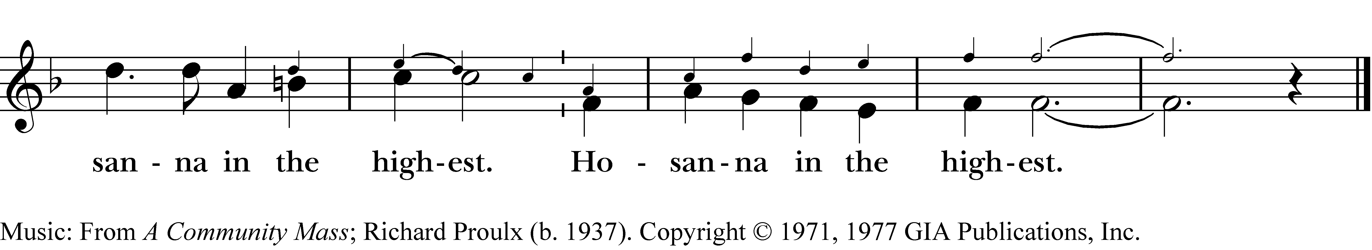
Stand or kneel as you are able
Then the Celebrant continues

And so, Father, we who have been redeemed by him, and made a new people by water and the Spirit, now bring before you these gifts. Sanctify them by your Holy Spirit to be the Body and Blood of Jesus Christ our Lord.

At the following words concerning the bread, the Celebrant is to hold it, or lay a hand upon it; and at the words concerning the cup, to hold or place a hand upon the cup and any other vessel containing wine to be consecrated.

On the night he was betrayed he took bread, said the blessing, broke the bread, and gave it to his friends, and said, “Take, eat: This is my Body, which is given for you. Do this for the remembrance of me.”

After supper, he took the cup of wine, gave thanks, and said, “Drink this, all of you: This is my Blood of the new Covenant, which is shed for you and for many for the forgiveness of sins. Whenever you drink it, do this for the remembrance of me.”

Remembering now his work of redemption, and offering to you this sacrifice of thanksgiving,
We celebrate his death and resurrection, as we await the day of his coming.

Lord God of our Fathers; God of Abraham, Isaac, and Jacob; God and Father of our Lord Jesus Christ: Open our eyes to see your hand at work in the world about us. Deliver us from the presumption of coming to this Table for solace only, and not for strength; for pardon only, and not for renewal.
Let the grace of this Holy Communion make us one body, one spirit in Christ, that we may worthily serve the world in his name.
Risen Lord, be known to us in the breaking of the Bread.

Accept these prayers and praises, Father, through Jesus
Christ our great High Priest, to whom, with you and the
Holy Spirit, your Church gives honor, glory, and worship, from generation to generation. AMEN.

And now, as our Savior
Christ has taught us,
we are bold to say,

People and Celebrant

Our Father, who art in heaven,
hallowed be thy Name,
thy kingdom come,
thy will be done,
on earth as it is in heaven.
Give us this day our daily bread.
And forgive us our trespasses,
as we forgive those
who trespass against us.
And lead us not into temptation,
but deliver us from evil.
For thine is the kingdom,
and the power, and the glory,
for ever and ever. Amen.

The Breaking of the Bread

The Celebrant breaks the consecrated Bread.

A period of silence is kept. Then may be sung or said

Fraction Anthem: The disciples knew the Lord Jesus
Wonder Love and Praise, #876
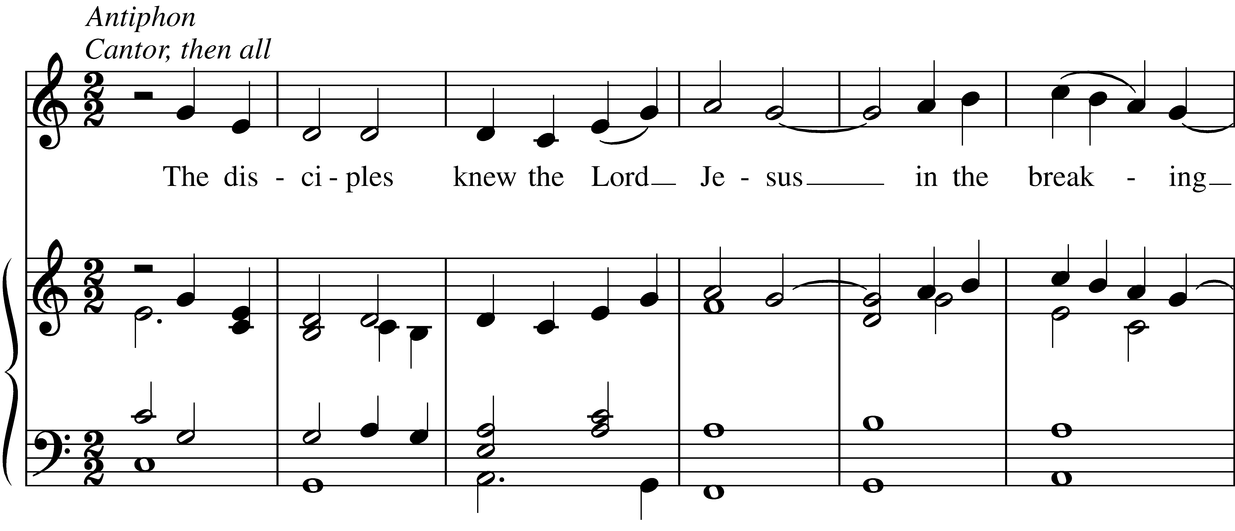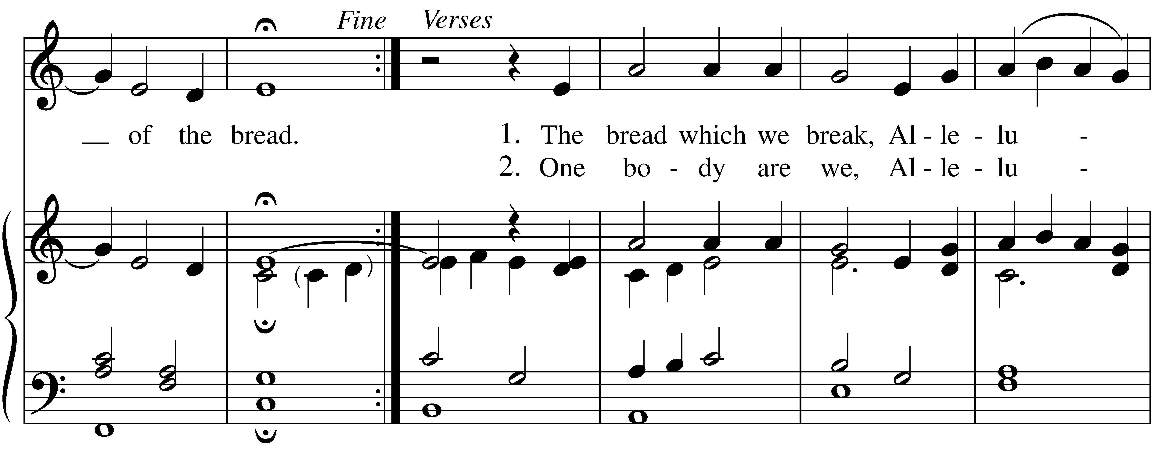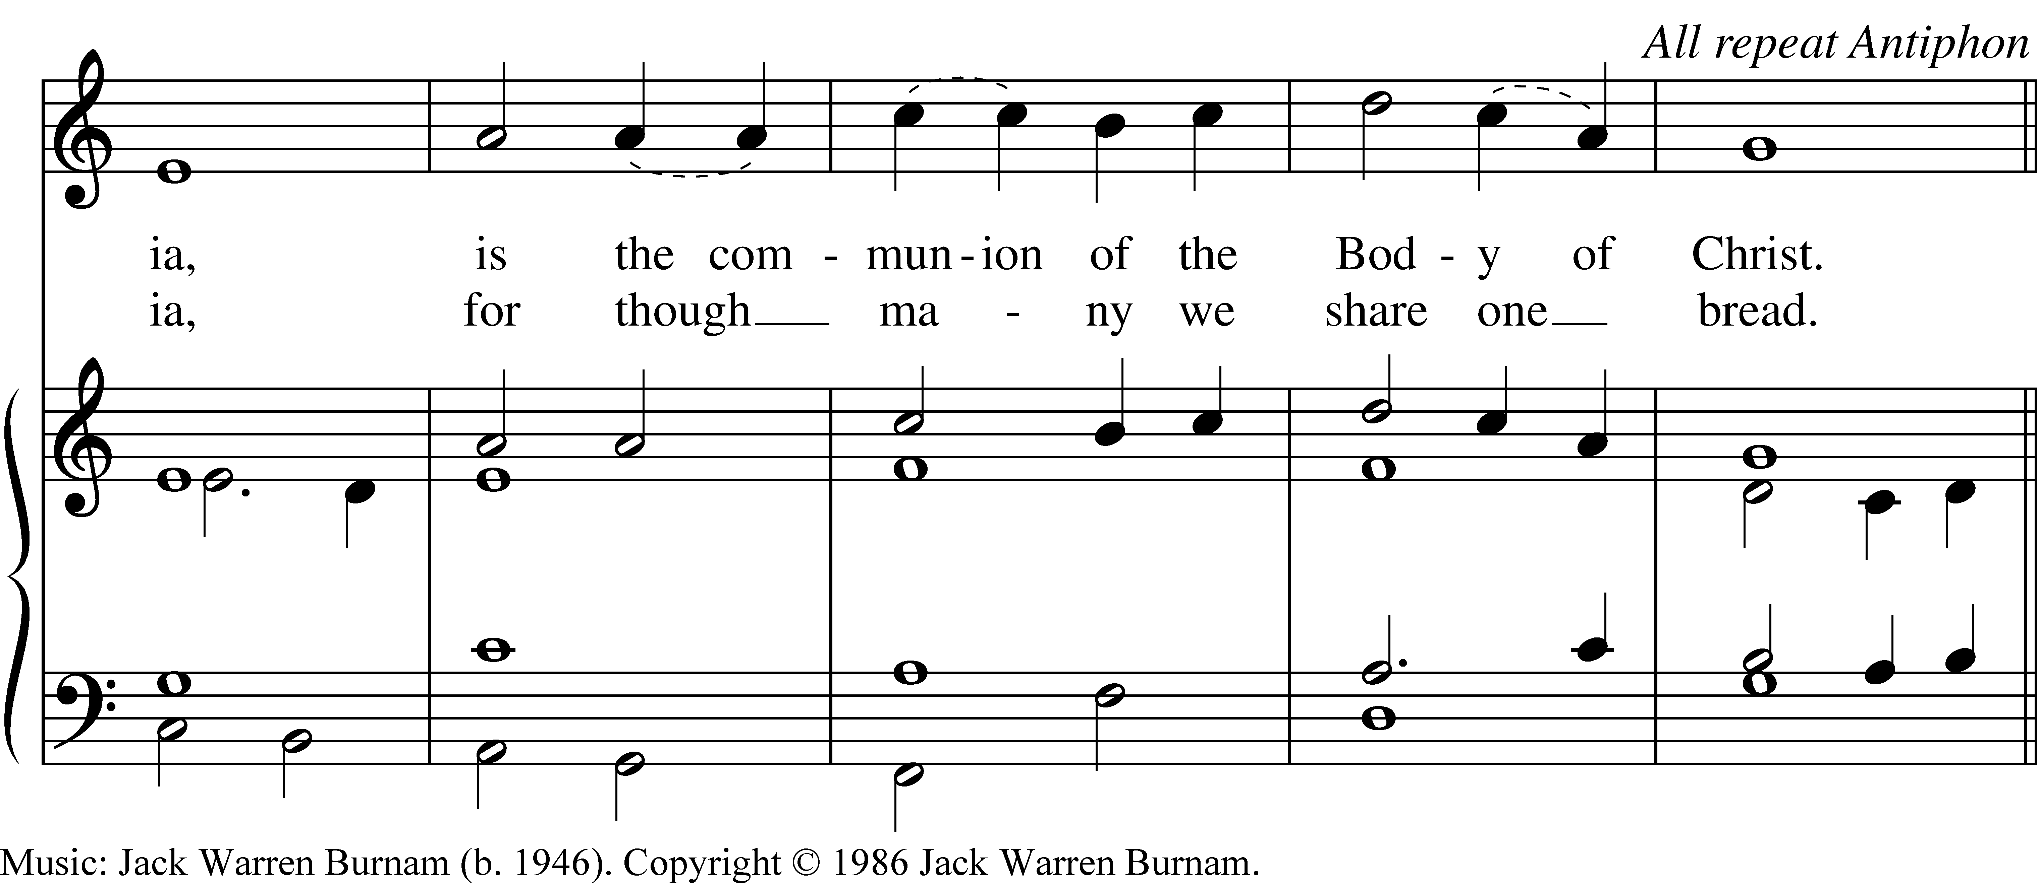
Facing the people, the Celebrant says the following Invitation

The Gifts of God for the People of God.

The ministers receive the Sacrament in both kinds, and then immediately deliver it to the people.

All are welcome at the Lord’s Table. If you do not wish to receive the bread and wine, please cross your arms across your chest to receive a blessing. Gluten-free wafers are available. If you need communion brought to you, please let an usher know.

The Bread and the Cup are given to the communicants with these words

The Body of Christ, the bread of heaven. [Amen.]
The Blood of Christ, the cup of salvation. [Amen.]

Music at Communion #488
1 Be thou my vision, O Lord of my heart;
all else be nought to me, save that thou art—
thou my best thought, by day or by night,
waking or sleeping, thy presence my light.

2 Be thou my wisdom, and thou my true word;
I ever with thee and thou with me, Lord;
thou my great Father; thine own may I be;
thou in me dwelling, and I one with thee.

3 High King of heaven, when victory is won,
may I reach heaven’s joys, bright heaven’s Sun!
Heart of my heart, whatever befall,
still be my vision, O Ruler of all.
Meditation after the Communion
Be still, be still,
Be still and know, be still and know.
Be still, and know I am God.
After Communion, the Celebrant says

Let us pray. (standing or kneeling)

Celebrant and People

Eternal God, heavenly Father, you have graciously accepted us as living members of your Son our Savior Jesus Christ, and you have fed us with spiritual food in the Sacrament of his Body and Blood. Send us now into the world in peace, and grant us strength and courage to love and serve you with gladness and singleness of heart; through Christ our Lord. Amen.

Blessing

Celebrant Life is short, and we do not have much time to gladden the hearts of those who make the journey with us. So be swift to love, and make haste to be kind. And the blessing of God, who made us, who loves us, and who travels with us, be with you now and for ever.
People Amen.

Hymn in Procession # 594 (standing as you are able)
1 God of grace and God of glory,
on thy people pour thy power;
crown thine ancient Church’s story;
bring her bud to glorious flower.
Grant us wisdom, grant us courage,
for the facing of this hour.

2 Lo! the hosts of evil round us
scorn thy Christ, assail his ways!
From the fears that long have bound us
free our hearts to faith and praise:
grant us wisdom, grant us courage
for the living of these days.

3 Cure thy children’s warring madness,
bend our pride to thy control;
shame our wanton, selfish gladness,
rich in things and poor in soul.
Grant us wisdom, grant us courage,
lest we miss thy kingdom’s goal.

4 Save us from weak resignation
to the evils we deplore;
let the gift of thy salvation
be our glory evermore.
Grant us wisdom, grant us courage,
serving thee whom we adore.
Dismissal
Let us go forth into the world,
to love and serve the Lord.
People Thanks be to God.

Copyrighted music used with permission under
ONE LICENSE #737635-A. All rights reserved.
Valid for: 12/16/22 – 12/15/23

PRAYERS AND REMEMBRANCES OF THE WEEK

Immediate Needs:
Emily
Erin Apperson
Beatrice Attuah & Lailaity
Cindy Blackwell
Bobbie Bledsoe
Tina Brown
Marie Carl
Jane Carper
Mazie Chilton
Ann Cochrane
Anne Cox
Sarah Springthorpe-Denmark
Debbie Dockery
Sonia Donnell
Marcus Ford
Ashley Fulk
Gus Galloway
Polly Hall
Linda Hicks
Steve Hines
Melissa Hopkins
Fred Johnson
Joy King
Gus Lewis
Kay MacAllen
Kitty Martin
Carol Mays
Linda McMillian
Arba Montgomery
Tammy Moore

TRINITY FAMILY IN THE ARMED SERVICES
OF OUR COUNTRY
Amanda Eads, Wesley Frye, Corbin Humphrey, Matt Kroupa, Glenn Lynch, Gordon Lynch, Haley Muething, John Nichols, Christopher Noble, Robert Poole

DIOCESAN CYCLE OF PRAYER
Church of the Nativity, Raleigh
St. Ambrose, Raleigh
St. Augustine’s University Chapel, Raleigh

BIRTHDAYS
July 31st Pat Gallagher,
August 2nd Beatrice Attuah, 3rd Mark Appler & Marci Pobgee

ANNIVERSARIES

August 4th Sid & Miki Spencer

Craig New
Wade Nichols

Bill R. Pendleton

Doug Pobgee

Sylvia Poggi

Kerry Reagan

Mac Sammons

Stephanie Serika
Emily Jarvis Simmons
Susan Slate
Wade Smith
Rose Mary Smoot
Johnny Springthorpe
Tammy Springthorpe
Sheila Storms
Sharon Sutphin
Celeste Tsaklis

Betty Wright

Pat Zebrowski

Long Term Needs:
Stacie Adams
Jean Amburn
*Anonymous
Tina Brown
Kat Cook
Mary Couture
Melissa Roth Culver
Roger Danley
Paul Derrick
Ron Doerschug

Linda Doerschug
Barbara Embry
Donna Fargo
Johnnie Gunter
Betty Hooven
Kelly Jarvis
Carrie Krahn
David Kroupa
Angelia Lawrence
Rebecca McNabb
John Moore
Michael Morgan

Angie Nolfo

Bill Pendleton

Beverly Putynkowski

Victoria Rogelin

Candace Sammons
Evedene Schafer
Sid Spencer, Jr.

Betty Town
Vicky Town
John Townsend
Jack Woltz

ANNOUNCEMENTS

If you would like to receive healing prayers and anointing while at the Altar rail please let Sarah know.

Are you interested in being the Staples Coordinator or helping with Staples? Please let Sarah know.

The new Forward Day by Day devotionals are available in the narthex.

Belize Lunch Program-St. Paul's Anglican School in Corozal, Belize, is once again trying to raise $5000 to benefit their lunch program for the next school year. The principal tells us that for $5000, they can buy the food and hire a cook. If you would like to make a contribution to their lunch program, you can write a check to Trinity and earmark it for Belize and we will get it to them.

Class for Confirmation, Reception, or Reaffirmation continues this Sunday from 9:30-10:15. This class is also for anyone who wants to go deeper in their faith or to revisit or learn the basics of our Episcopal tradition. If you are interested but can’t come to this class, please let Sarah know.

Our next Backyard Bible Study will be held on Thursday, August 3rd at
6:00 p.m. If you would like to volunteer to host, please let Sarah know. We
will have a potluck supper, fellowship, and study Revelation.

The next First Sunday Potluck will be on Sunday, August 6th. We need volunteers to help with setting up before and cleaning up after. If you can help, please contact Roxann Moore at 336-336-429-2618.

It’s that time again! The Mount Airy Walk to End Alzheimer’s is Sept. 9th at Riverside Park. Won’t you join Team Trinity and walk with us or make a donation to support our efforts? Our goal is $3000 and we might even surpass that with your help. Contact Margie Martin for more information. Registration and Donation forms can be found in the Narthex and in the Parish Hall.

Tobi will be on vacation beginning Friday, July 28th and will be back in the office on Monday, August 7th.

If you are visiting, please fill out a Visitor Card and put it in the offering plate or hand it to a greeter. Restrooms are located downstairs.

FLOWERS
The flowers on the altar are given to the glory of God and
in loving memory of our fathers, Joseph W. Cook and G. Thomas Fawcett, Sr.
by Tom & Mary Fawcett.

MINISTERS FOR THE 8:30 SERVICE
Today Ministry Next Sunday
Jessica Simandle LECTOR Nancy Dixon
Jim Couture CHALICE BEARER Mike Wilson
Mary Fawcett GREETER Pat Sanderson
Tom Fawcett ACOLYTE Mike Wilson

MINISTERS FOR THE 10:30 SERVICE
This Sunday Ministry Next Sunday
Denny Jennings LECTOR Brenda Goings
Roxann Moore CHALICE BEARER Jesse Slate
Gloria & Larry GREETERS Bill & Janet
Jane & Pam ALTAR GUILD Brenda Goings
Roxann Moore VESTRY Ann Vaughn
Karen Nealis ACOLYTE Roxann Moore

THIS WEEK'S EVENTS
Today 8:30 a.m. Holy Eucharist
9:30 a.m. Confirmation Class
10:30 a.m. Holy Eucharist

Tuesday 10:00 a.m. Medical Loan Closet

Wednesday 5:30 p.m. Holy Eucharist

Thursday 8:30 a.m. Staples
3:00 p.m. Loan Closet
6:00 p.m. Backyard Bible Study

Saturday 5:00 p.m. AA Meeting

Next Sunday 8:30 a.m. Holy Eucharist
9:30 a.m. Confirmation Class
10:30 a.m. Holy Eucharist
First Sunday Potluck

TRINITY VESTRY

Ross Borders, Margie Martin, Roxann Moore,

James Tatman, Ann Vaughn, Mike Wilson, Lee Wilsonwithers

No matter where you come from or where you're going
No matter what you believe or what you doubt
No matter what you feel or just don't feel today
No matter whom you love
You are welcome into this space to be met by a God
Who knows you by name, who knows your heart, who knows your mind, and…
Who wants to have a relationship with you

